A SAMPLE FOR FORMATTING AN ARTICLE IN ENGLISH

INITIAL OBSERVATIONS ON THE GRAMMATICAL CHARACTERISTICS, INFLUENCED BY LANGUAGE CONTACT, IN THE SPEECH OF BILINGUALS SPEAKING BULGARIAN AND LADINO

Diana Klüh. Tania Avgustinova
Saarland University

The paper reports the initial observations on the speech of five bilingual speakers of Bulgarian and Ladino. The aim is to establish the grammatical characteristics, triggered by the situation of language contact……………………………….
………………………………………………………………………………………………………………………………………………………………………………………………………………………………………………………………………………………………………………
Key words: Ladino, language contact, Judeo-Spanish

В статье представлены предварительные наблюдения над разговорами пятерых билингвов, которые являются носителями болгарского языка и ладино. Задача – установить грамматические характеристики, заданные языковым контактом…………………………………………………………………………………………………...

…………………………………………TEXT…………………………………………………..
……………………………………………………………………………………………………..
……………………………………………………………………………………………………..
……………………………………………………………………………………………………..

Table 1

Diagram 1

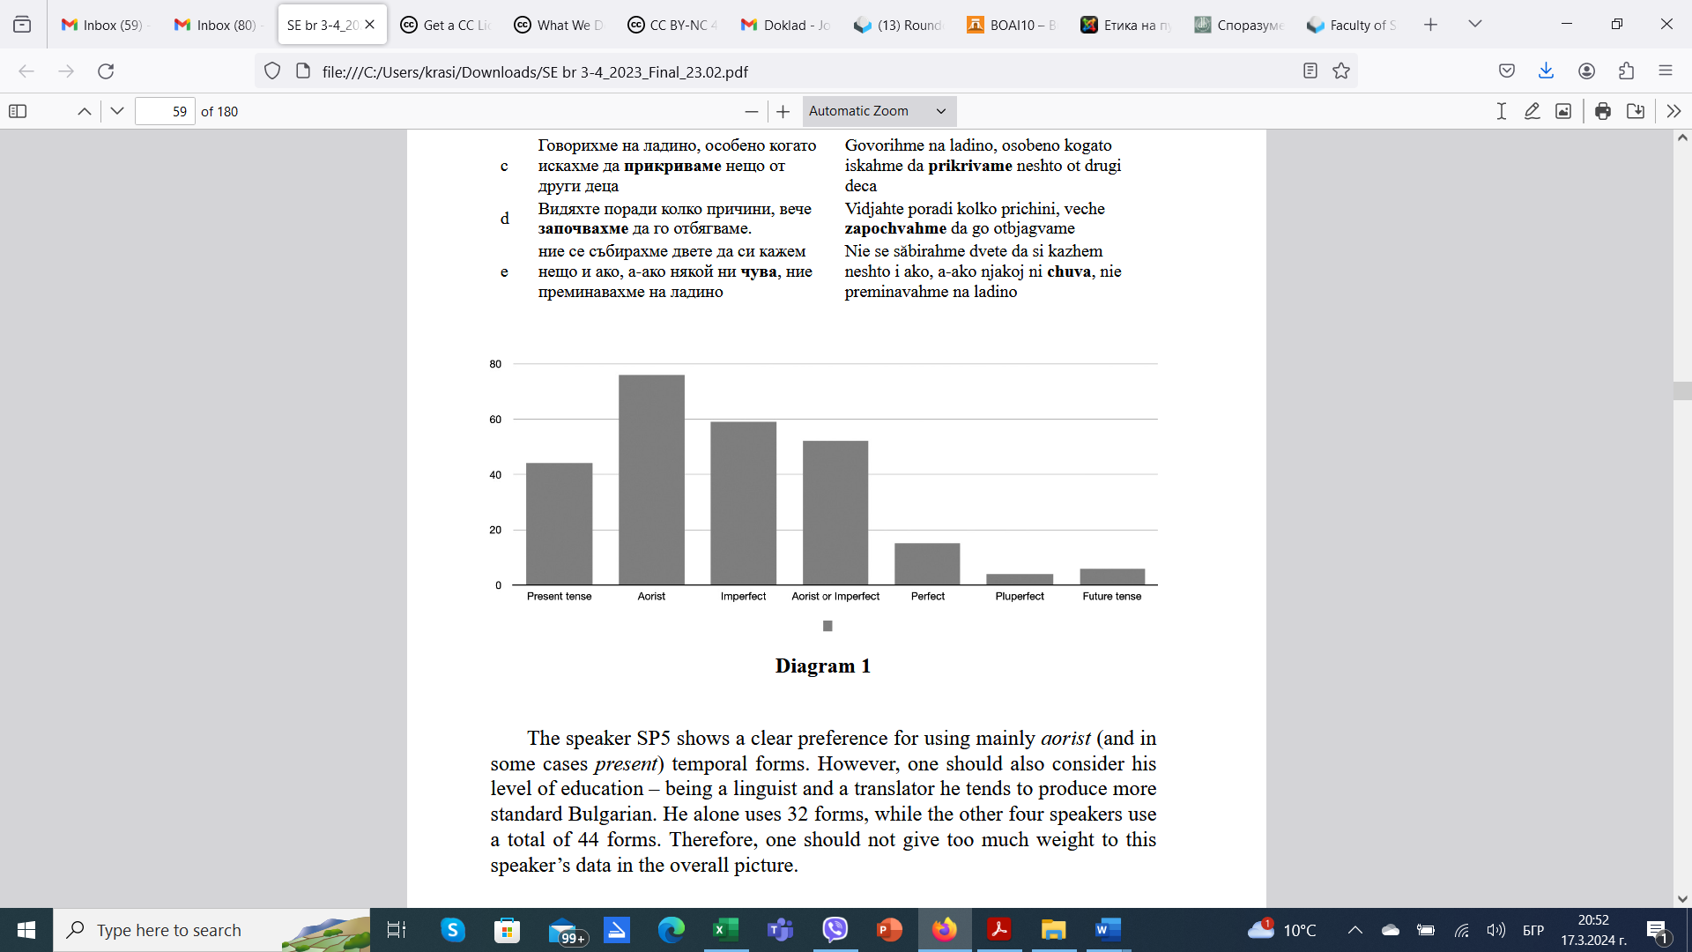

……………………………………………………………………………………………………..
……………………………………………………………………………………………………..
……………………………………………………………………………………………………..

ACKNOWLEDGMENTS & FUNDING

……………………………………………………………………………………………………..
……………………………………………………………………………………………………..

REFERENCES

BOWERMAN, M. 1983. Reorganization processes in lexical and syntactic development. In: WANNER, E., GLEITMAN, L. (eds.). Language acquisition: The state of art. Cambridge: Cambridge University Press, pp. 319 – 346.
STOYKOV, St. 2002. Balgarska dialektologia. 4-to fototipno izd. Sofia: Akademichno izdatelstvo „Prof. Marin Drinov“.
RADDEN, G., DIRVEN, R. 2007. Cognitive English Grammar. Amsterdam/Philadelphia: John Benjamin Publishing House. DOI: https://doi.org/10.1075/clip.2.
……………………………………………………………………………………
……………………………………………………………………………………

ЛИТЕРАТУРА

СТОЙКОВ, Ст. 2002. Българска диалектология. 4-то фототипно изд. София: Академично издателство „Проф. Марин Дринов“.
……………………………………………………………………………………
……………………………………………………………………………………

Prof. Dr. Diana Klüh
ORCID: ………………………..
Web of Science ResearcherID:……………. Scopus Author ID:……….
Department of Language Science and Technology
Saarland University
Saarbruken, Germany
E-mail: ххххххххххххххх@xxxxx.xxx

Prof. Dr. phil. habil. Tania Avgustinova
ORCID: ………………………..
Web of Science ResearcherID:……………. Scopus Author ID:……….
Department of Language Science and Technology
Saarland University
Saarbruken, Germany
E-mail: ххххххххххххххх@xxxxx.xxx

